# Lorawan node met Wemos D1 Mini en RFM95.

RM95 Top view:

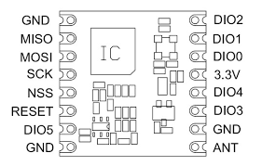

## WeMos D1Mini -> RFM95

|  |  |  |
| --- | --- | --- |
| RFM95 | D1 mini | Descr. |
| RESET | RST | Reset switch |
| NSS | D8 - GPIO15 | CS/SS |
| SCK | D5 - GPIO14 | SPI - SCK |
| MOSI | D7 - GPIO13 | SPI - MOSI |
| MISO | D6 - GPIO12 | SPI - MISO |
| GND | GND | Ground |
| 3.3V | 3.3V | 3.3 Volt |
| DIO0 | D2 - GPIO4 | IRQ |
| DIO1 | D1 - GPIO5 | DIO1 |

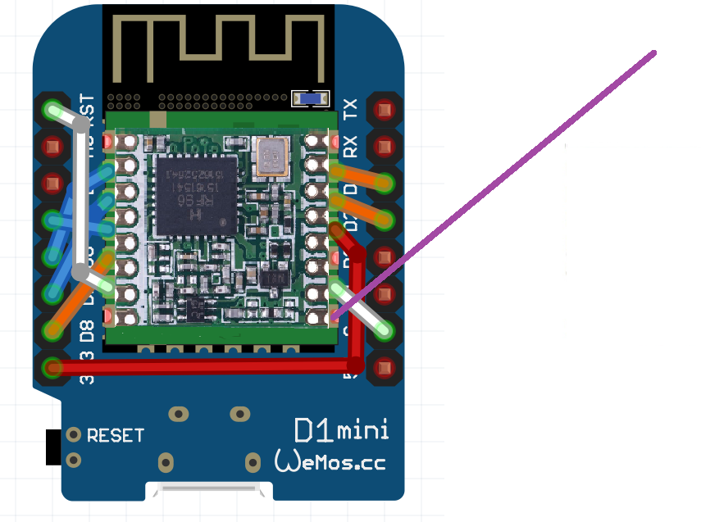

De RFM95 zit geplakt op de ESP8266 en de verbindingen zijn aangebracht. De paarse draad is de antenne van ongeveer 8.6 cm.

In the Arduino sketch, the lmic must be as follows. Note that the GPIO port number should be used and not the WeMos port numbers.

lmic_pinmap lmic_pins = {  
.nss = 15,  
.rxtx = LMIC_UNUSED_PIN,  
.rst = LMIC_UNUSED_PIN,  
.dio = { 4, 5, LMIC_UNUSED_PIN },  
} ;